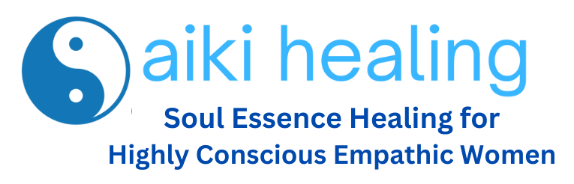

Application for the Soul Essence Sisterhood Healing Circle

What is the Soul Essence Sisterhood Healing Circle?

This special year-long membership journey is for highly conscious empathic women who have experienced narcissistic attacks and injuries or other forms of deep trauma—and who need deeper quantum (DNA) level tools to restore their souls, improve their physical health and heal those stubborn patterns that seem to elude traditional and even other holistic therapies.

How Does it Work?

Entrance into this sacred healing circle is by invitation only—and we only accept 10 applications in a year. The membership is $25,000 annually.

Once accepted into the circle, you will experience:

- A weekly power medical qi gong movement healing that ignites the power of your cells to release trauma from your bodies and align you with the highest frequencies of God’s healing energy.

- Once a month power ignition workshop to help you purify and release toxic energy as you release trauma layers, strengthen your filters so you can prevent toxic energy from re-forming, and align to God’s frequency to manifest the life that He has created just for you.

- Unlimited access to the Get Your Mojo Back cohorts and Herbal Healing journeys to attend as many times as you like during the year.

- One-on-one mentoring to deepen and accelerate your personal growth.

Application Questions
Take a deep breath and get centered.

You may wish to watch this 2-minute video to quiet your mind so you can reflect deeply to fill out this application. https://www.youtube.com/watch?v=IGwC7t4Sink

When you finish, please email it to aikihealing@gmail.com

Name

Email

Phone

Address

Who are You as an Empathic Woman?
Take as much space below to help me to understand your unique walk as an empathic woman.

You might wish to share about what kind of work you do or what fills your time daily—what you’re passionate about, and what challenges you experience with emotional overwhelm or exhaustion daily.

What has been your experience with interacting with a narcissist? What has been the impact on your feelings, life and soul?

What do you hope to gain in your growth by being a part of our sacred healing circle?

On a scale of 1 to 10, where 10 is high and 1 is very low, how would you rate your current sense of emotional overwhelm or anxiety?

On a scale of 1 to 10 where 10 is burnt out and 1 is energized, how would you rate your level of daily exhaustion?

What tools do you currently use to manage stress?

How consistent are you with those tools?

What would need to happen in 60 days to make you feel as you are making headway in your recovery from narcissistic attacks?

Describe a dream come true—what your life would look like if your wounds from narcissistic attacks were well healed?

Are you ready to invest in yourself

